
PATUAKHALI SCIENCE AND TECHNOLOGY UNIVERSITY
COURSE CODE CIT-112

SUBMITTED TO:

Md. Mahbubur Rahman

Department of Computer Science and Information Technology
Faculty of Computer Science and Engineering

SUBMITTED BY:
Md. Sharafat Karim
ID: 2102024,
Registration No: 10151
Faculty of Computer Science and Engineering

Date of submission: 13 April, 2023
Assignment: 05

7.1 Reversing digits
#include<stdio.h>
int main()
{
int n;
scanf("%d", &n);
int reverse=0;
while (n>0)
{
reverse *= 10;
reverse += n % 10;
n /= 10;
}
printf("%d", reverse);
}
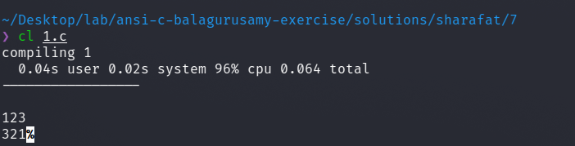

7.10
#include <stdio.h>
int main()
{
float accuracy = 0.00001;
float result=1, sum = 1;
int i = 1;
while ( sum > accuracy )
{
result += sum;
i++;
sum *= ((float)1/i);
}
printf("Result -> %f", result);
}
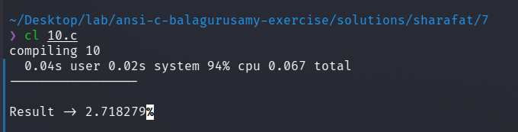

7.11
#include <stdio.h>
#include <math.h>
int main()
{
float accuracy = 0.0001, x;
scanf("%f", &x);
float result=1, sum = x;
int i = 1;
while ( sum > accuracy || sum < 0 )
{
result += sum;
i += 2;
sum *= (-1)*(x*x)/(i*(i-1));
if (i >= 100)
break;
}
printf("sinx -> %f\n", result);
result=1, sum = 1;
i = 0;
while ( sum > accuracy || sum < 0 )
{
result += sum;
i += 2;
sum *= (-1)*(x*x)/(i*(i-1));
if (i >= 100)
break;
}
printf("cosx -> %f\n", result);
result=1, sum = 1;
i = 0;
while ( sum > accuracy || sum < 0 )
{
result += sum;
i += 1;
sum *= pow(((float)1/i),i);
if (i >= 100)
break;
}
printf("SUM -> %f\n", result);
}
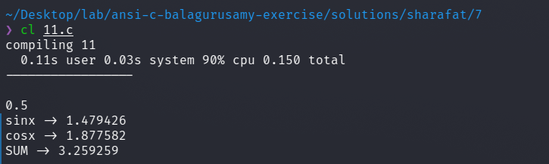

7.12
#include <math.h>
#include <stdio.h>
#include <ctype.h>
int input(char name)
{
int n;
printf("Enter the value of %c\n", name );
scanf("%d", &n);
if (n >= 0)
return n;
else
{
printf("Invalid input! Please try again\n");
printf("Value of P is -> %d", n);
return input(name);
}
}
int main()
{
int n, c, d;
c = input('c');
d = input('d');
n = input('n');
int P;
P = c * pow(( 1 - (int)(d/100) ), n);
printf("Value of P is -> %d", P);
return 0;
}
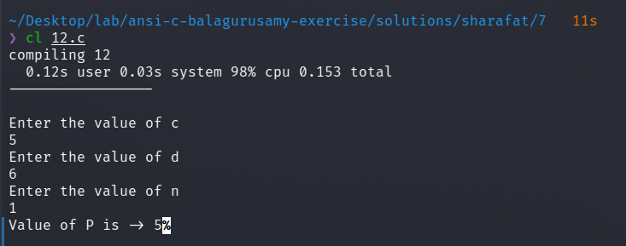

7.13
#include<stdio.h>
int main()
{
int i, j;
int col = 5;
char Char = 'S';
for (i=0; i< col; i++)
{
for (j=0; j<col; j++)
{
printf("%c ", Char);
}
printf("\n");
}
printf("\n");
for (i=0; i< col; i++)
{
for (j=0; j<col; j++)
{
if (i==0||j==0||i==col-1||j==col-1)
printf("%c ", Char);
else
printf(" ");
}
printf("\n");
}
}
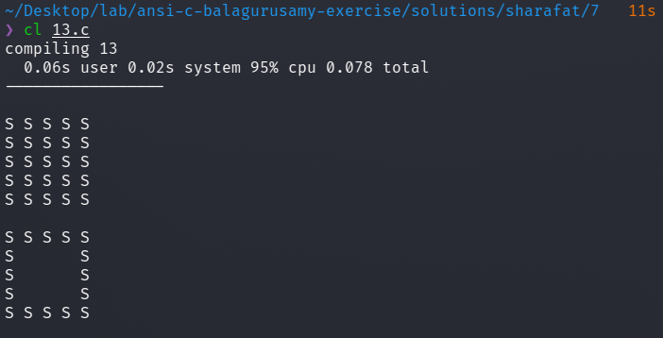

7.14
#include <stdio.h>
#include <math.h>
/*
x y
--------------------------
0 0.000000
15 0.258819
30 0.500000
45 0.707107
60 0.866025
75 0.965926
90 1.000000
105 0.965926
120 0.866025
135 0.707107
150 0.500000
165 0.258819
180 0.000000
*/
#define PI 3.14159265
int main()
{
int i;
float j, s;
for (j=1.1; j >= 0; j-=0.1)
{
for (i=0; i<= 180; i+= 15)
{
s = sin(i*PI/180);
if (fabsf(s-j)<=0.1)
{
printf("*");
}
else {
printf(" ");
}
}
printf("\n");
}
}
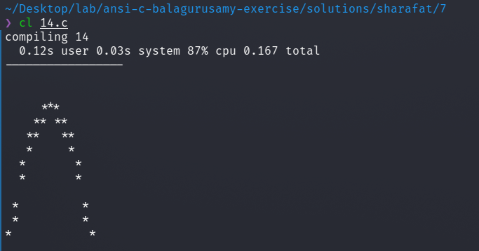

7.15
#include<stdio.h>
int main()
{
int i, j;
int col = 5;
char Char = 'S';
char Char2 = 'O';
for (i=0; i< col; i++)
{
for (j=0; j<col; j++)
{
if (i==j && i==2)
printf("%c ", Char2);
else
printf("%c ", Char);
}
printf("\n");
}
}
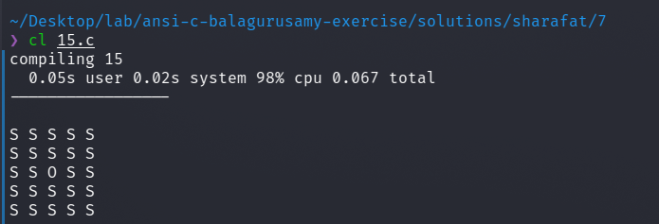

7.16
#include<stdio.h>
int main()
{
int i, j;
int sum=0;
for (i=0; i< 10; i++)
{
scanf("%d", &j);
sum += j;
printf("%d + ", j);
}
printf("\nSum -> %d", sum);
}
// test case
// 1 2 3 4 5 6 7 8 9 10

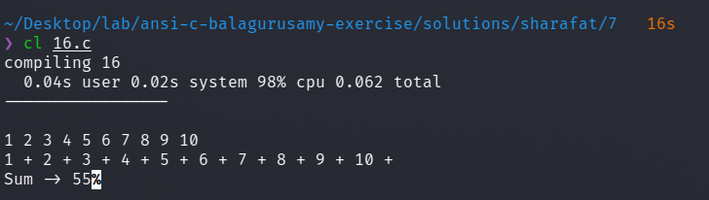

7.17
#include <stdio.h>
void red () {
printf("\033[1;31m");
}
void yellow() {
printf("\033[1;33m");
}
void reset () {
printf("\033[0m");
}
int main () {
red();
printf("Hello ");
yellow();
printf("world\n");
red();
printf("---------------------------\n");
reset();
return 0;
}

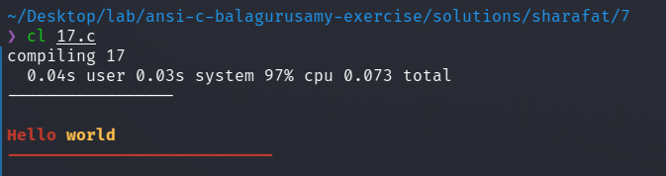

7.18
#include<stdio.h>
int main()
{
int i, j;
int digit=1;
char letter='A';
int n;
scanf("%d", &n);
for (i=0; i< n; i++)
{
for (j=0; j<(5-i);j++)
printf(" ");
for (j=0; j<= i; j++)
{
if (i%2==0)
printf("%d ", digit++);
else
printf("%c ", letter++);
}
printf("\n");
}
}
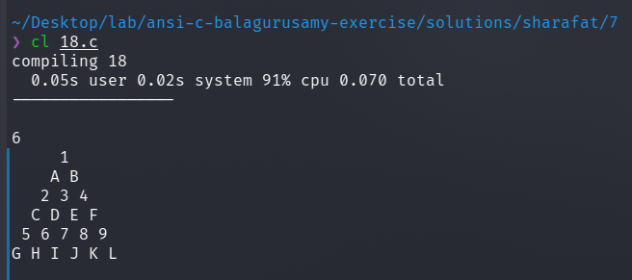

7.19
#include<stdio.h>
int main()
{
int i, j;
int digit=1;
char letter='A';
int n;
scanf("%d", &n);
for (i=0; i< n/2; i++)
{
for (j=0; j<(5-i);j++)
printf(" ");
for (j=1; j<= i+1; j++)
printf("%d ", j);
for (j=j-2;j>=1;j--)
printf("%d ", j);
printf("\n");
}
for (i=n/2; i>= 0; i--)
{
for (j=0; j<(5-i);j++)
printf(" ");
for (j=1; j<= i+1; j++)
printf("%d ", j);
for (j=j-2;j>=1;j--)
printf("%d ", j);
printf("\n");
}
}
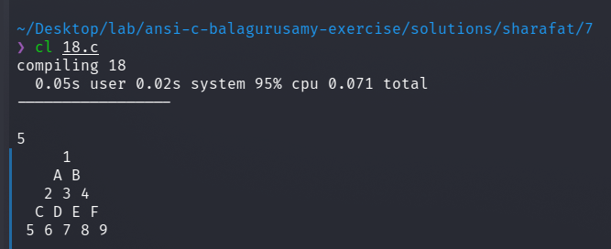

7.2
#include<stdio.h>
int main()
{
int n;
scanf("%d", &n);
int sum=0;
while (n>0)
{
sum += n % 10;
n /= 10;
}
printf("%d", sum);
}
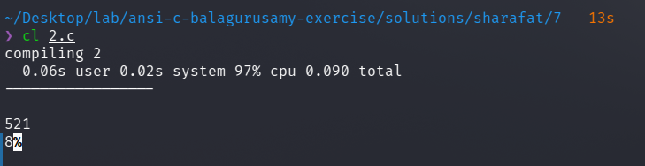

7.20
#include<stdio.h>
int main()
{
int i, j;
int digit=1;
char letter='A';
int n;
scanf("%d", &n);
for (i=0; i< n; i++)
{
for (j=0; j<= i; j++)
printf("%d ", ((i+j)%2==0?1:0));
printf("\n");
}
}
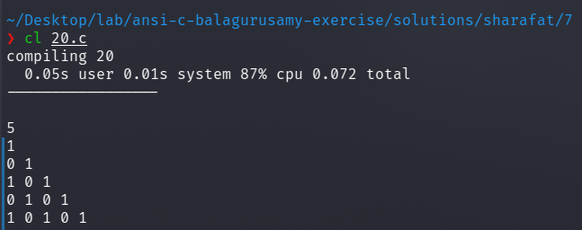

7.3
#include<stdio.h>
int main()
{
int n;
scanf("%d", &n);
int i=0, j=1, k=1, l=0, sum=0;
do
{
if ( i == 0 || i == 1 )
sum += 1;
else
{
sum += j + k;
l = j + k;
k = j;
j = l;
}
i++;
} while (i<n);
printf("%d", sum);
}
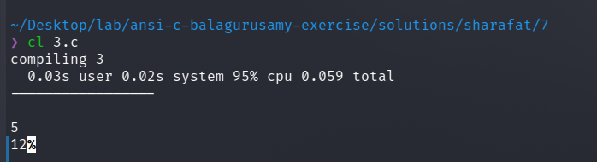

7.4
#include<stdio.h>
int main()
{
int n=1;
int p=1000, V ; float r=0.10;
do
{
V = p * (1+r);
printf("P - %d , V - %d , n - %d \n", p, V, n++);
p = V;
} while ( p <= 10000 );
}
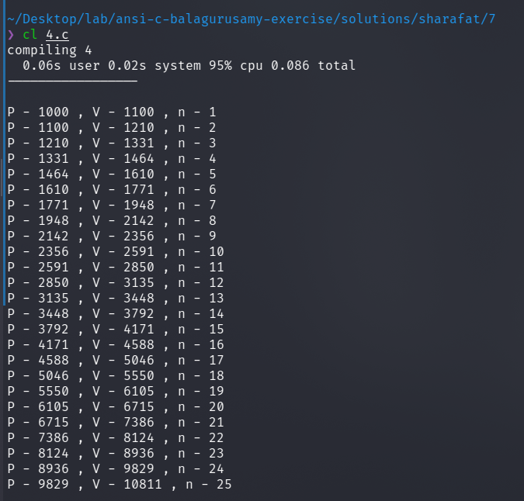

7.5
#include <stdio.h>
int main()
{
int n;
scanf("%d", &n);
int i, j;
for (i=0; i<n; i++)
{
for (j=1; j<=i+1; j++)
printf("%d ", i+1);
printf("\n");
}
printf("\n");
for (i=0; i<n; i++)
{
for (j=0; j<i; j++)
printf(" ");
for ( j=n-i ; j>0 ; j-- )
printf("* ");
printf("\n");
}
}
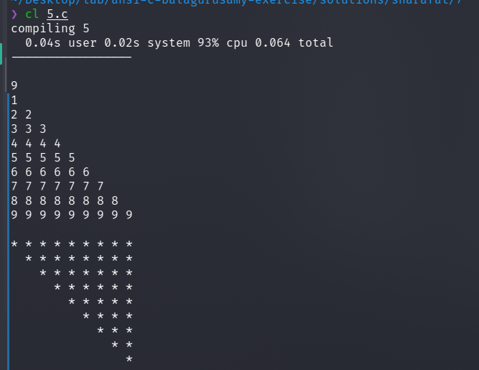

7.6
#include<stdio.h>
int main()
{
int i, j;
int sum = 0;
for (i=0; i<100; i++)
{
scanf("%d", &j);
if ( 50 <= j && j <= 60 )
{
sum++;
continue;
}
}
printf("total - %d", sum);
}
// test cases
// 84 29 50 5 96 36 47 77 16 30 39 79 63 40 19 76 42 57 97 48 69 24 98 55 73 3 25 60 92 46 26 44 23 95 65 45 15 59 62 51 85 20 71 87 31 4 8 66 99 7 54 89 37 6 70 1 56 81 75 90 2 17 28 88 14 11 82 18 94 13 49 22 61 9 10 21 64 32 91 67 58 33 93 38 83 34 12 41 78 72 27 74 80 43 68 86 35 100 53 52
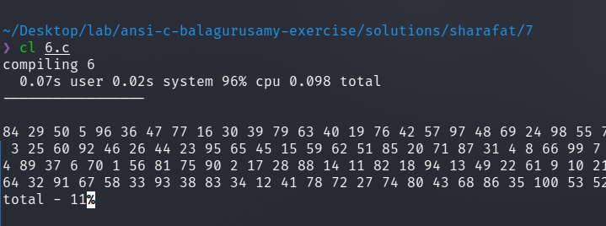

7.7
#include<stdio.h>
#include <math.h>
int main()
{
int i;
float a, x, y1, y2;
a = 0.4;
printf(" y --------> \n");
printf("-------------------------------------\n");
for (x=0; x<5; x= x + 0.25)
{
y1 = (int) (50*exp(-a * x)+0.5);
y2 = (int) (50*exp(-a * x + x/2)+0.5);
if (y1 == y2)
{
if (x==2.5)
printf(" X |");
else
printf("|");
for (i=1; i <= y1-1; ++i)
printf(" ");
printf("#\n");
continue;
}
if (y1>y2)
{
if ( x == 2.5 )
printf(" X |");
else
printf(" |");
for (i=1; i <= y2-1; ++i )
printf(" ");
printf("*");
for ( i = 1; i <= (y1 - y2-1);++i)
printf("-");
continue;
}
if (x==2.5)
printf(" X |");
else
printf(" |");
for (i = 1; i <= (y1 - 1); ++i)
printf(" ");
printf("0");
for (i = 1; i <= (y2-y1-1); ++i)
printf("-");
printf("*\n");
}
printf(" |n");
float j, s;
for (j=1.1; j >= 0; j-=0.1)
{
for (i=0; i<= 5; i+= 0.5)
{
s = exp(-a * x);
if (fabsf(s-j)<=0.1)
{
printf("*");
}
else {
printf(" ");
}
}
printf("\n");
}
}
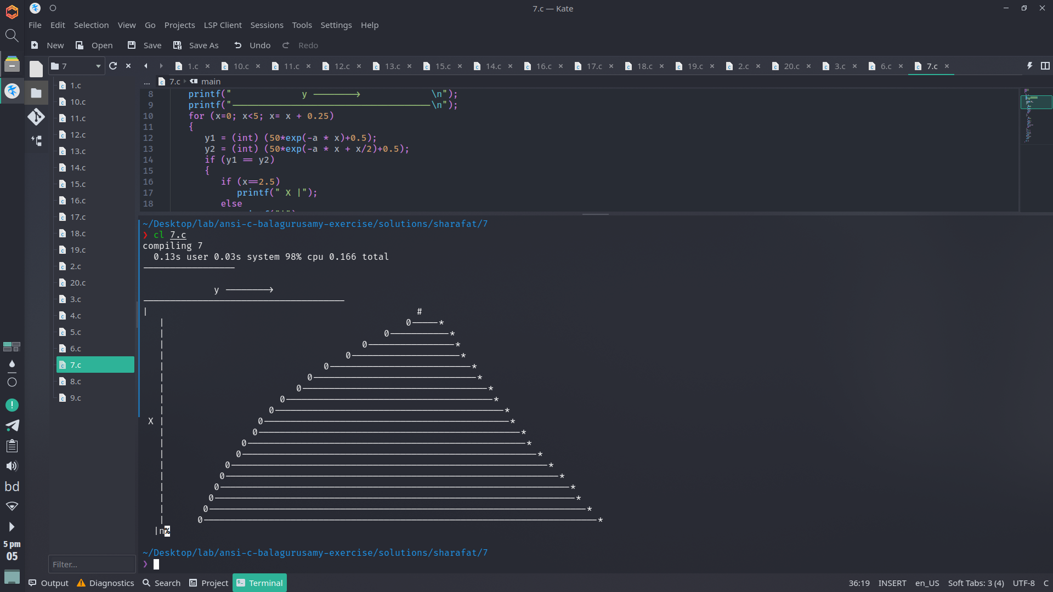

7.8
#include<stdio.h>
#include <math.h>
int main()
{
float x, y;
x = 0.0;
float i, j;
for (i=0; i<= (float)(0.91) ; i += 0.1)
{
if (i==0)
printf(" X ");
else
printf(" %.1f ", i);
}
printf("\n");
for (i=0; i<= 9 ; i += 1)
{
for (j=i; j<=i+0.91; j += 0.1)
{
if (j==i)
printf(" %.1f ", j);
else
printf(" %.1e ", exp(-j));
}
printf("\n");
}
printf("\n");
}
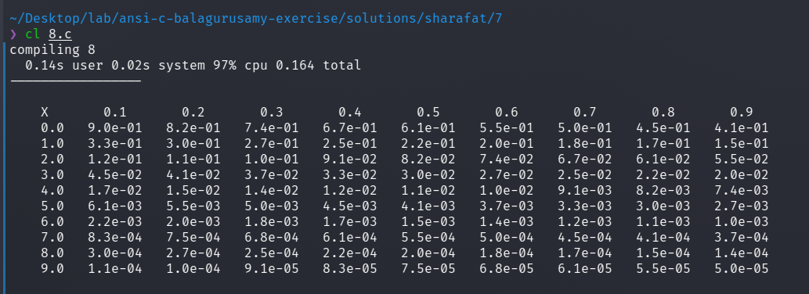

7.9
#include <stdio.h>
int main() {
int rows = 15;
int cols = 18;
int i, j;
for (i = 0; i < cols; i++)
printf("*");
printf("\n");
for (i = 0; i < cols; i++)
{
if (i < 2 || i > 15)
printf("*");
else
printf("-");
}
printf("\n");
for (i = 0; i < cols; i++)
{
if (i < 9 || i > 15)
printf("*");
else
printf("-");
}
printf("\n");
for (i = 0; i < cols; i++)
{
if (i < 4 )
printf("*");
}
printf("\n");
for (i = 0; i < cols; i++)
{
if (i < 4 )
printf("*");
}
printf("\n");
for (i = 0; i < cols; i++)
{
if (i < 4 )
printf("*");
}
printf("\n");
for (i = 0; i < cols; i++)
{
if (i < 5 || i > 13)
printf("*");
else
printf("-");
}
printf("\n");
for (i = 0; i < cols; i++)
{
if (i > 13)
printf("*");
else
printf("-");
}
printf("\n");
for (i = 0; i < cols; i++)
{
if (i > 13)
printf("*");
else
printf("-");
}
printf("\n");
for (i = 0; i < cols; i++)
{
if (i > 13)
printf("*");
else
printf("-");
}
printf("\n");
for (i = 0; i < cols; i++)
{
if (i > 13)
printf("*");
else
printf("-");
}
printf("\n");
for (i = 0; i < cols; i++)
{
if (i > 13)
printf("*");
else
printf("-");
}
printf("\n");
for (i = 0; i < cols; i++)
{
if (i > 13)
printf("*");
else
printf("-");
}
printf("\n");
for (i = 0; i < cols; i++)
{
if (i < 4 || i > 13)
printf("*");
else
printf("-");
}
printf("\n");
for (i = 0; i < cols; i++)
{
if (i < 3 || i > 13)
printf("*");
else
printf("-");
}
printf("\n");
for (i = 0; i < cols; i++)
{
if (i < 2 || i > 13)
printf("*");
else
printf("-");
}
printf("\n");
return 0;
}

